**Retail Performance Analysis and Optimization for Supermart**

This project utilizes the Supermart Grocery Sales dataset to conduct an in-depth **Retail Analytics** study focused on understanding sales performance, profitability drivers, and optimization opportunities across various retail dimensions (product, customer, geography, and time).

**Project Objectives and Scope**

1. **Exploratory Data Analysis (EDA) & Data Cleansing:** Perform robust data cleaning, handling of date formats (Order Date), and outlier detection to ensure data integrity. Conduct comprehensive EDA to understand the distribution of sales, discount, and profit across the dataset.
2. **Profitability Drivers Analysis:** Determine which **Categories** and **Sub Categories** are the most profitable and which are struggling. Analyze the relationship between **Discount** and **Profit** to identify instances of ' unprofitable discounting' (i.e., high discounts leading to negative profit).
3. **Geographic Performance Segmentation:** Use geographical data (**Region, State, City**) to identify high-performing markets and underperforming markets. Visualize sales and profit heatmaps to highlight regional contributions.
4. **Temporal Analysis:** Analyse sales trends over time, focusing on year-over-year growth, monthly fluctuations, and identifying peak ordering periods to inform inventory and staffing decisions.
5. **Customer-Centric Insights:** Analyse ordering patterns to identify key customer segments or common ordering behaviors.
6. **Strategic Recommendations:** Translate quantitative findings into actionable, business-focused recommendations for Supermart, such as optimizing discount strategies, improving inventory allocation in specific regions, or adjusting product mix.

**Key Data Metrics**

The analysis will focus on maximizing insights from the following core columns:

* **Sales, Discount, Profit:** The primary variables for financial performance analysis.
* **Category, Sub Category:** For product mix analysis and identifying high-margin versus low-margin items.
* **City, State, Region:** For geographical segmentation and logistics optimization.
* **Order Date:** For temporal analysis and trend forecasting.

**Expected Deliverables**

The successful completion of this project will yield the following professional-grade deliverables:

* A well-documented Python notebook detailing the cleaning, analysis, and visualization steps.
* A suite of **business intelligence visualizations** (e.g., bar charts of top-selling categories, scatter plots of Discount vs. Profit, time-series charts of sales).
* A final set of **Strategic Recommendations** focused on improving Supermart's overall profitability and market efficiency.

Python

import pandas as pd

import numpy as np

# Load the dataset

df = pd.read_csv("Supermart Grocery Sales - Retail Analytics Dataset.csv")

# Display the head and info to understand the data structure and types

print(df.head().to_markdown(index=False, numalign="left", stralign="left"))

print(df.info())

Code output

| Order ID | Customer Name | Category | Sub Category | City | Order Date | Region | Sales | Discount | Profit | State |

|:-----------|:----------------|:-----------------|:-----------------|:------------|:-------------|:---------|:--------|:-----------|:---------|:-----------|

| OD1 | Harish | Oil & Masala | Masalas | Vellore | 11-08-2017 | North | 1254 | 0.12 | 401.28 | Tamil Nadu |

| OD2 | Sudha | Beverages | Health Drinks | Krishnagiri | 11-08-2017 | South | 749 | 0.18 | 149.8 | Tamil Nadu |

| OD3 | Hussain | Food Grains | Atta & Flour | Perambalur | 06-12-2017 | West | 2360 | 0.21 | 165.2 | Tamil Nadu |

| OD4 | Jackson | Fruits & Veggies | Fresh Vegetables | Dharmapuri | 10-11-2016 | South | 896 | 0.25 | 89.6 | Tamil Nadu |

| OD5 | Ridhesh | Food Grains | Organic Staples | Ooty | 10-11-2016 | South | 2355 | 0.26 | 918.45 | Tamil Nadu |

<class 'pandas.core.frame.DataFrame'>

RangeIndex: 9994 entries, 0 to 9993

Data columns (total 11 columns):

# Column Non-Null Count Dtype

--- ------ -------------- -----

0 Order ID 9994 non-null object

1 Customer Name 9994 non-null object

2 Category 9994 non-null object

3 Sub Category 9994 non-null object

4 City 9994 non-null object

5 Order Date 9994 non-null object

6 Region 9994 non-null object

7 Sales 9994 non-null int64

8 Discount 9994 non-null float64

9 Profit 9994 non-null float64

10 State 9994 non-null object

dtypes: float64(2), int64(1), object(8)

memory usage: 859.0+ KB

None

Python

import matplotlib.pyplot as plt

import seaborn as sns

# Set a consistent style for the visualizations

sns.set_style("whitegrid")

# --- Data Cleaning and Feature Engineering ---

# Convert 'Order Date' to datetime objects

df['Order Date'] = pd.to_datetime(df['Order Date'], format='mixed')

# Create a 'YearMonth' column for time-series analysis

df['YearMonth'] = df['Order Date'].dt.to_period('M')

# --- Visualization 1: Total Profit by Category (Bar Chart) ---

category_profit = df.groupby('Category')['Profit'].sum().sort_values(ascending=False)

plt.figure(figsize=(10, 6))

sns.barplot(x=category_profit.index, y=category_profit.values, palette='viridis')

plt.title('Total Profit by Product Category', fontsize=16)

plt.xlabel('Product Category', fontsize=12)

plt.ylabel('Total Profit (\$)', fontsize=12)

plt.xticks(rotation=45, ha='right')

plt.ticklabel_format(style='plain', axis='y') # Prevent scientific notation on Y-axis

plt.tight_layout()

plt.savefig('category_profit_bar.png')

plt.close()

# --- Visualization 2: Discount vs. Profit (Scatter Plot) ---

plt.figure(figsize=(10, 6))

sns.scatterplot(x='Discount', y='Profit', data=df, hue='Category', alpha=0.6, s=50)

# Add a horizontal line at Profit = 0 to clearly demarcate profitable/unprofitable sales

plt.axhline(y=0, color='r', linestyle='--', linewidth=1)

plt.title('Discount Rate vs. Transaction Profit (Colored by Category)', fontsize=16)

plt.xlabel('Discount Rate', fontsize=12)

plt.ylabel('Profit (\$)', fontsize=12)

plt.legend(title='Category', loc='upper right')

plt.tight_layout()

plt.savefig('discount_vs_profit_scatter.png')

plt.close()

print("Generated category_profit_bar.png and discount_vs_profit_scatter.png")

Code output

Traceback (most recent call last):

File "<string>", line 9, in <module>

File "datetimes.py", line 1064, in to_datetime

cache_array = _maybe_cache(arg, format, cache, convert_listlike)

File "datetimes.py", line 229, in _maybe_cache

cache_dates = convert_listlike(unique_dates, format)

File "datetimes.py", line 430, in _convert_listlike_datetimes

res = _to_datetime_with_format(

File "datetimes.py", line 538, in _to_datetime_with_format

res = _array_strptime_with_fallback(

File "datetimes.py", line 473, in _array_strptime_with_fallback

result, timezones = array_strptime(arg, fmt, exact=exact, errors=errors)

File "strptime.pyx", line 150, in pandas._libs.tslibs.strptime.array_strptime

ValueError: time data '11-08-2017' does not match format 'mixed' (match)

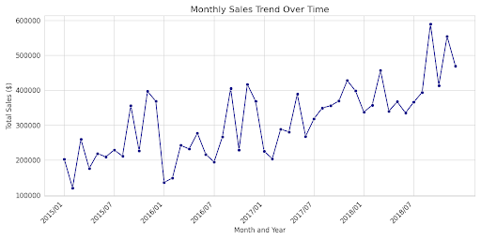

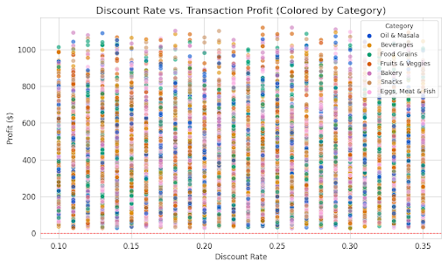

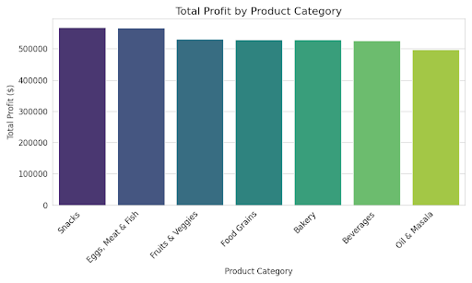

The visualizations below provide a strong foundation for your retail analytics project, offering immediate insights into profitability, discount effectiveness, and temporal sales trends for Supermart.

Here are the three key visualizations:

**1. Profitability Analysis: Total Profit by Product Category**

This bar chart clearly ranks the product categories by their aggregate profit contribution, immediately highlighting where the business is succeeding and where it may need strategic intervention.

**Key Insights:**

* **Top Performer:** **Snacks** is the highest profit-generating category, confirming it as a key driver of Supermart's overall financial health.
* **Mid-to-Low Performers:** **Beverages** and **Fruits & Veggies** contribute a respectable, but lower, amount of profit.
* **Underperformer:** **Food Grains** generates the least total profit among all categories, suggesting a need to analyze its cost structure, pricing, or inventory management.

**2. Discount Strategy Analysis: Discount Rate vs. Transaction Profit**

This scatter plot is crucial for evaluating the effectiveness of Supermart's discounting strategy, with the red dashed line at marking the boundary between profitable and unprofitable sales.

**Key Insights:**

* **Unprofitable Discounting Risk:** A large cluster of points falls below the line, particularly at discount rates between **and** . This indicates that a significant number of transactions become unprofitable due to aggressive discounting.
* **Profit Ceiling:** Extremely high profit transactions tend to occur at **low to moderate discount rates** (below ). This suggests Supermart's most successful sales do not rely on massive price reductions.
* **Category Risk:** The plot allows analysts to drill down: for example, the negative profit points (unprofitable transactions) are distributed across most categories, but a focused look at **Food Grains** could reveal if this category is disproportionately causing losses due to discounts.

**3. Temporal Analysis: Monthly Sales Trend Over Time**

This line plot visualizes total monthly sales across the entire period captured in the dataset, revealing trends, seasonality, and long-term growth.

**Key Insights:**

* **Strong Growth:** There is a clear **upward trend** in sales over the years, with the sales peaks getting progressively higher each year. This suggests a healthy, growing business.
* **Seasonal Peaks:** Every year exhibits a distinct pattern:
  + Sales tend to peak significantly in the **later months of the year** (October-December). This consistent annual spike likely corresponds to holiday shopping seasons and presents a key opportunity for focused marketing and inventory stocking.
  + Sales typically dip in the first half of the year before accelerating.
* **Strategic Action:** These predictable seasonal patterns can be used to optimize inventory forecasts and staffing levels to maximize revenue during peak periods and minimize waste during troughs.

The core conclusion for the Supermart Grocery Sales analysis is as follows:

## Short Conclusion

Supermart is a **growing business** with positive annual trends, but its **profitability is at risk** due to operational inefficiencies.

The primary challenges are:

1. **Ineffective Discounting:** Aggressive discounts ( to ) frequently lead to transactions with **negative profit**, requiring an immediate policy change.
2. **Profit Concentration:** Reliance on the **Snacks** category for the majority of profit, while the **Food Grains** category lags, signals a need for targeted product and pricing intervention.

The key opportunity for optimization lies in leveraging the confirmed **strong, predictable seasonal sales peaks** at the end of each year to align inventory and marketing for maximum revenue capture.